**Chapter 6**

**Vector Calculus**

**6.4 Green’s Theorem**

**Section Exercises**

**For the following exercises, evaluate the line integrals by applying Green’s theorem.**

1.  where *C*is the path from (0, 0) to (1, 1) along the graph of  and from (1, 1) to (0, 0) along the graph of oriented in the counterclockwise direction

Answer: 

1.  where *C* is the boundary of the region lying between the graphs of  and  oriented in the counterclockwise direction

Answer: 

1.  where *C* is defined by  oriented in the counterclockwise direction

Answer: 

149  where *C* is the boundary of the region lying between the graphs of  and  oriented in the counterclockwise direction

Answer: 

1.  where *C* is the boundary of the region lying between the graphs of  and  oriented in the counterclockwise direction

Answer: 

1.  where *C*consists of line segment *C*1from to (1, 0), followed by the semicircular arc *C*2from (1, 0) back to (1, 0)

Answer: 

**For the following exercises, use Green’s theorem.**

1. Let *C* be the curve consisting of line segments from (0, 0) to (1, 1) to (0, 1) and back to (0, 0). Find the value of 

Answer: 

1. Evaluate line integral  where *C* is the boundary of

the region between circles  and  and is a positively oriented curve.

Answer: 

1. Find the counterclockwise circulation of field  around and

over the boundary of the region enclosed by curves  and  in the first quadrant and oriented in the counterclockwise direction.

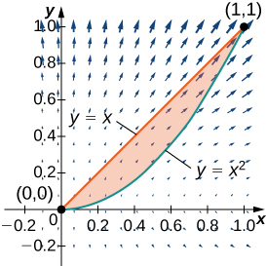

Answer: circulation 

1. Evaluate  where *C* is the positively oriented circle of radius 2

centered at the origin.

Answer: 

1. Evaluate  where *C* includes the two circles of radius 2 and radius 1 centered at the origin, both with positive orientation.

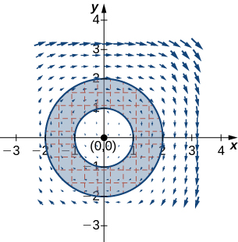

Answer: 

1. Calculate  where *C* is a circle of radius 2 centered at the origin and oriented in the counterclockwise direction.

Answer: 

1. Calculate integral  along triangle *C* with vertices (0, 0), (1, 0) and (1, 1), oriented counterclockwise, using Green’s theorem.

Answer: 

1. Evaluate integral  where *C* is the curve that follows parabola  then the line from (2, 4) to (2, 0), and finally the line from (2, 0) to (0, 0).

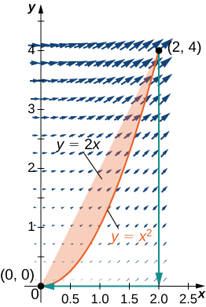

Answer: 

1. Evaluate line integral  where *C* is oriented in a counterclockwise path around the region bounded by  and 

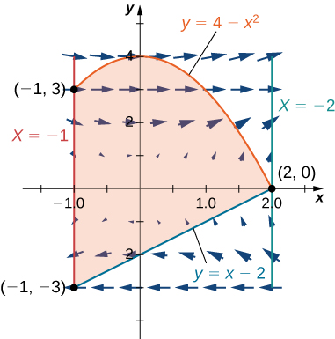

Answer: 

**For the following exercises, use Green’s theorem to find the area.**

1. Find the area between ellipse  and circle 

Answer: 

1. Find the area of the region enclosed by parametric equation

 for 

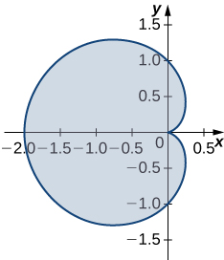

Answer: 

1. Find the area of the region bounded by hypocycloid  The curve is parameterized by 

Answer: 

1. Find the area of a pentagon with vertices  and 

Answer: 

1. Use Green’s theorem to evaluate  where is the perimeter of square  oriented counterclockwise.

Answer: 

1. Use Green’s theorem to prove the area of a disk with radius a is 

Answer: 

1. Use Green’s theorem to find the area of one loop of a four-leaf rose  (*Hint*:  ).

Answer: 

1. Use Green’s theorem to find the area under one arch of the cycloid given by parametric plane

Answer: 

1. Use Green’s theorem to find the area of the region enclosed by curve



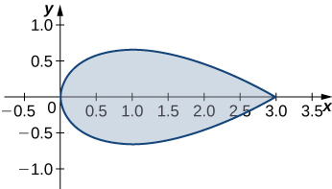

Answer: 

1. **[T]**Evaluate Green’s theorem using a computer algebra system to evaluate the integral  where *C* is the circle given by and is oriented in the counterclockwise direction.

Answer: 

1. Evaluate  where *C* is the boundary of the unit square  traversed counterclockwise.

Answer: 

1. Evaluate  where *C* is any simple closed curve with an interior that does not contain point  traversed counterclockwise.

Answer: 

1. Evaluate , where *C* is any piecewise, smooth simple closed curve enclosing the origin, traversed counterclockwise.

Answer: 

**For the following exercises, use Green’s theorem to calculate the work done by force F on a particle that is moving counterclockwise around closed path *C*.**

1.  

Answer: 

1.  *C* : boundary of a triangle with vertices (0, 0), (5, 0), and (0, 5)

Answer: 

1. Evaluate  where *C* is a unit circle oriented in the counterclockwise direction.

Answer: 

1. A particle starts at point  moves along the *x*-axis to (2, 0), and then travels along semicircle  to the starting point. Use Green’s theorem to find the work done on this particle by force field 

Answer: 

1. David and Sandra are skating on a frictionless pond in the wind. David skates on the inside, going along a circle of radius 2 in a counterclockwise direction. Sandra skates once around a circle of radius 3, also in the counterclockwise direction. Suppose the force of the wind at point  is  Use Green’s theorem to determine who does more work.

Answer:  The fact that the answer is positive means the outside skater (Sandra) does more work.

1. Use Green’s theorem to find the work done by force field  when an object moves once counterclockwise around ellipse 

Answer: 

180. Use Green’s theorem to evaluate line integral  where *C*is ellipse  oriented counterclockwise.

Answer: 

181. Evaluate line integral  where *C*is the boundary of a triangle with vertices  with the counterclockwise orientation.

Answer: 

1. Use Green’s theorem to evaluate line integral  if  where *C*is a triangle with vertices (1, 0), (0, 1), and  traversed counterclockwise.

Answer: 

1. Use Green’s theorem to evaluate line integral  where *C*is a triangle with vertices (0, 0), (1, 0), and (1, 3) oriented clockwise.

Answer: 

184. Use Green’s theorem to evaluate line integral  where *C*is a circle  oriented counterclockwise.

Answer: 

1. Use Green’s theorem to evaluate line integral  where *C*is circle  oriented in the counterclockwise direction.

Answer: 

1. Use Green’s theorem to evaluate line integral  where *C*is ellipse  and is oriented in the counterclockwise direction.

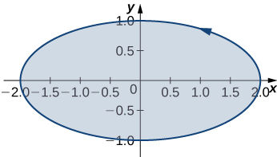

Answer: 

1. Let *C*be a triangular closed curve from (0, 0) to (1, 0) to (1, 1) and finally back to (0, 0). Let  Use Green’s theorem to evaluate 

Answer: 

188. Use Green’s theorem to evaluate line integral  where *C*is circle  oriented in the clockwise direction.

Answer: 

189. Use Green’s theorem to evaluate line integral  where *C*is any smooth simple closed curve joining the origin to itself oriented in the counterclockwise direction.

Answer: 

1. Use Green’s theorem to evaluate line integral  where C is the positively oriented circle 

Answer: 

191. Use Green’s theorem to evaluate  where *C*is a triangle with vertices (0, 0), (1, 0), and (1, 2) with positive orientation.

Answer: 

192. Use Green’s theorem to evaluate line integral where *C*is ellipse  oriented in the counterclockwise direction.

Answer: 

1. Let  Find the counterclockwise circulation  where *C*is a curve consisting of the line segment joining half circle  the line segment joining (1, 0) and (2, 0), and half circle 

Answer: 

194. Use Green’s theorem to evaluate line integral where *C*is a triangular closed curve that connects the points (0, 0), (2, 2), and (0, 2) counterclockwise.

Answer: 

195. Let *C*be the boundary of square  traversed counterclockwise. Use Green’s theorem to find 

Answer: 

196. Use Green’s theorem to evaluate line integral  where  and *C*is a triangle bounded by  oriented counterclockwise.

Answer: 

197. Use Green’s Theorem to evaluate integral  where  and *C*is a unit circle oriented in the counterclockwise direction.

Answer: 

1. Use Green’s theorem in a plane to evaluate line integral  where *C*is a closed curve of a region bounded by  oriented in the counterclockwise direction.

Answer: 

1. Calculate the outward flux of  over a square with corners  where the unit normal is outward pointing and oriented in the counterclockwise direction.

Answer: 

1. **[T]**Let *C* be circle  oriented in the counterclockwise direction. Evaluate  using a computer algebra system.

Answer: 

1. Find the flux of field  across  oriented in the counterclockwise direction.

Answer: 

1. Let  and let *C*be a triangle bounded by  and  oriented in the counterclockwise direction. Find the outward flux of **F** through *C*.

Answer: 

1. **[T]** Let *C* be unit circle  traversed once counterclockwise. Evaluate  by using a computer algebra system.

Answer: 

1. **[T]** Find the outward flux of vector field  across the boundary of annulus  using a computer algebra system.

Answer: 

1. Consider region *R* bounded by parabolas  Let *C* be the boundary of *R* oriented counterclockwise. Use Green’s theorem to evaluate 

Answer: 

**Student Project**

**Measuring Area from a Boundary: The Planimeter**

1. Explain why the total distance through which the wheel rolls the small motion just described is 

Answer: This is a proof; therefore, no answer is provided.

1. Show that 

Answer: This is a proof; therefore, no answer is provided.

1. Use step 2 to show that the total rolling distance of the wheel as the tracer traverses curve *C* is

Answer: This is a proof; therefore, no answer is provided.

**Total wheel roll **

**Now that you have an equation for the total rolling distance of the wheel, connect this equation to Green’s theorem to calculate area *D* enclosed by *C*.**

1. Show that 

Answer: This is a proof; therefore, no answer is provided.

1. Assume the orientation of the planimeter is as shown in [link]Figure_16_04_SP3[/link]. Explain why  and use this inequality to show there is a unique value of *Y* for each point  

Answer: This is a proof; therefore, no answer is provided.

1. Use step 5 to show that 

Answer: This is a proof; therefore, no answer is provided.

1. Use Green’s theorem to show that 

Answer: This is a proof; therefore, no answer is provided.

1. Use step 7 to show that the total wheel roll is

Total wheel roll 

Answer: This is a proof; therefore, no answer is provided.

**It took a bit of work, but this equation says that the variable of integration *Y* in step 3 can be replaced with *y*.**

1. Use Green’s theorem to show that the area of *D* is  The logic is similar to the logic used to show that the area of 

Answer: This is a proof; therefore, no answer is provided.

1. Conclude that the area of *D* equals the length of the tracer arm multiplied by the total rolling distance of the wheel.

Answer: This is a proof; therefore, no answer is provided.

This file is copyright 2016, Rice University. All Rights Reserved.